  - +1. Base Model
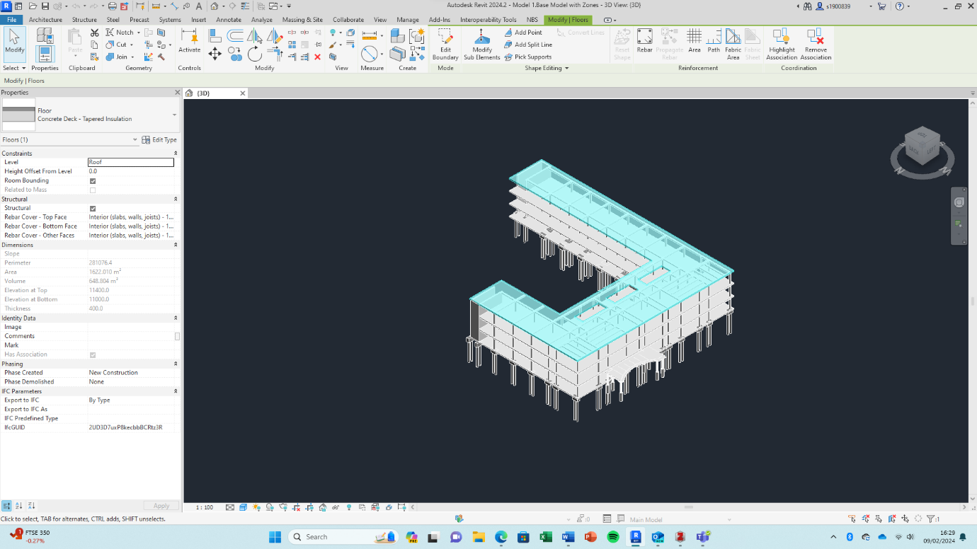
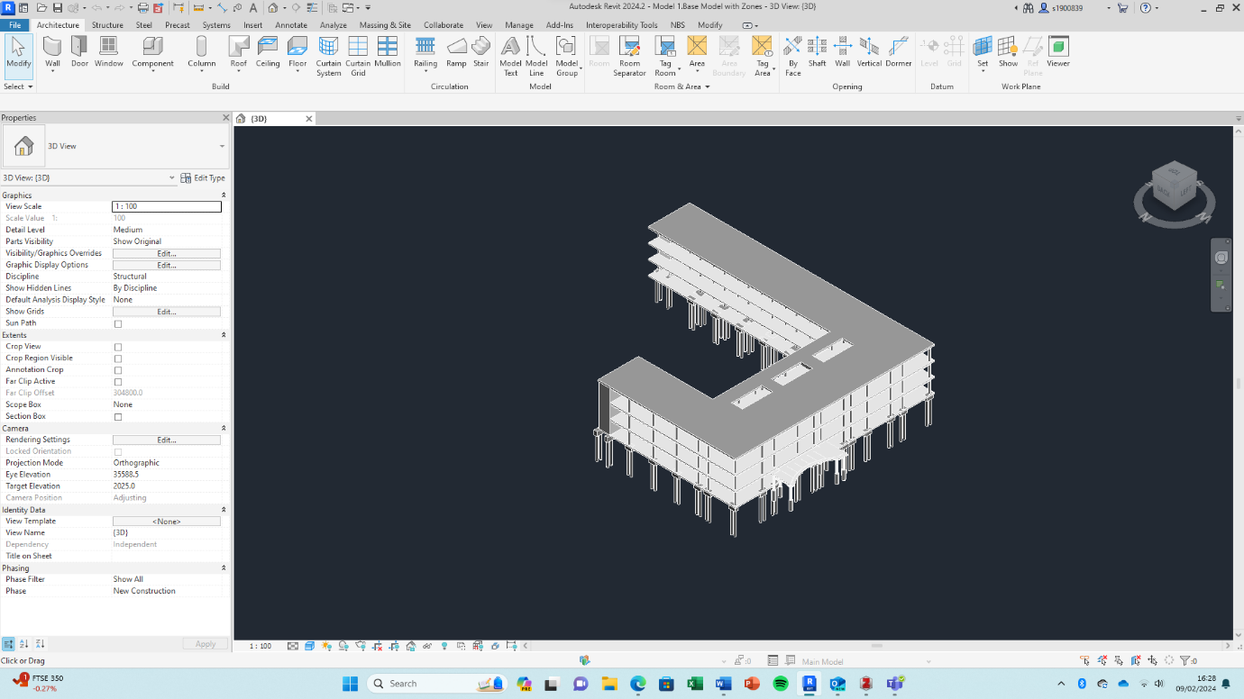
The base model is the model where nothing has been changed or altered for the automation process. This is the model which the scheduler would receive from the designer, modeller etc.

  - 2. Base Model with Zones & GridLine
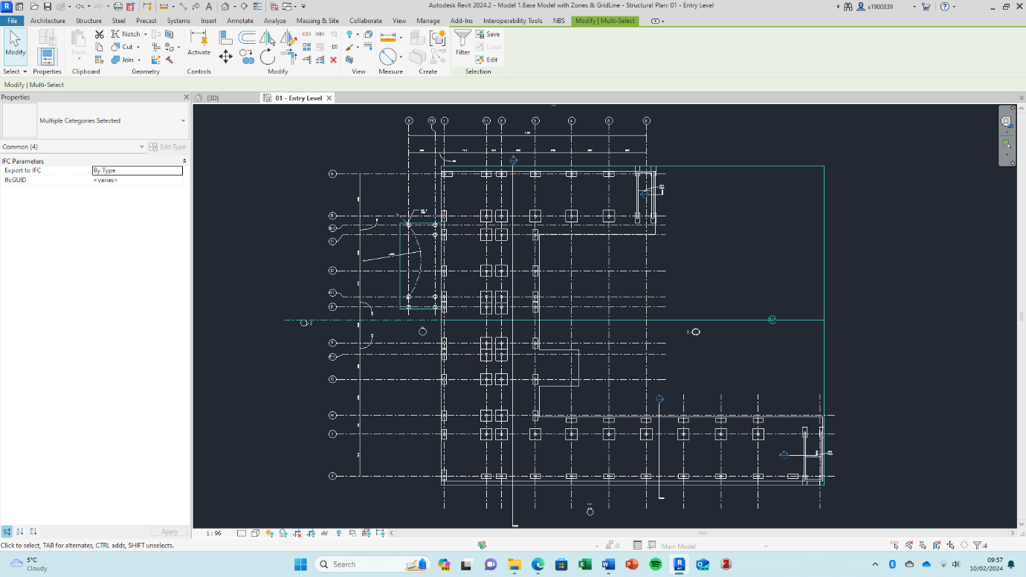
Zones are used to identify the construction areas, it helps with scheduling the sequencing of work. Naming convention is A,B,C etc. As many zones can be used as required for the sequencing of the works, mention slab construction or rail construction. Grid line used to accurately divide model and place masses.
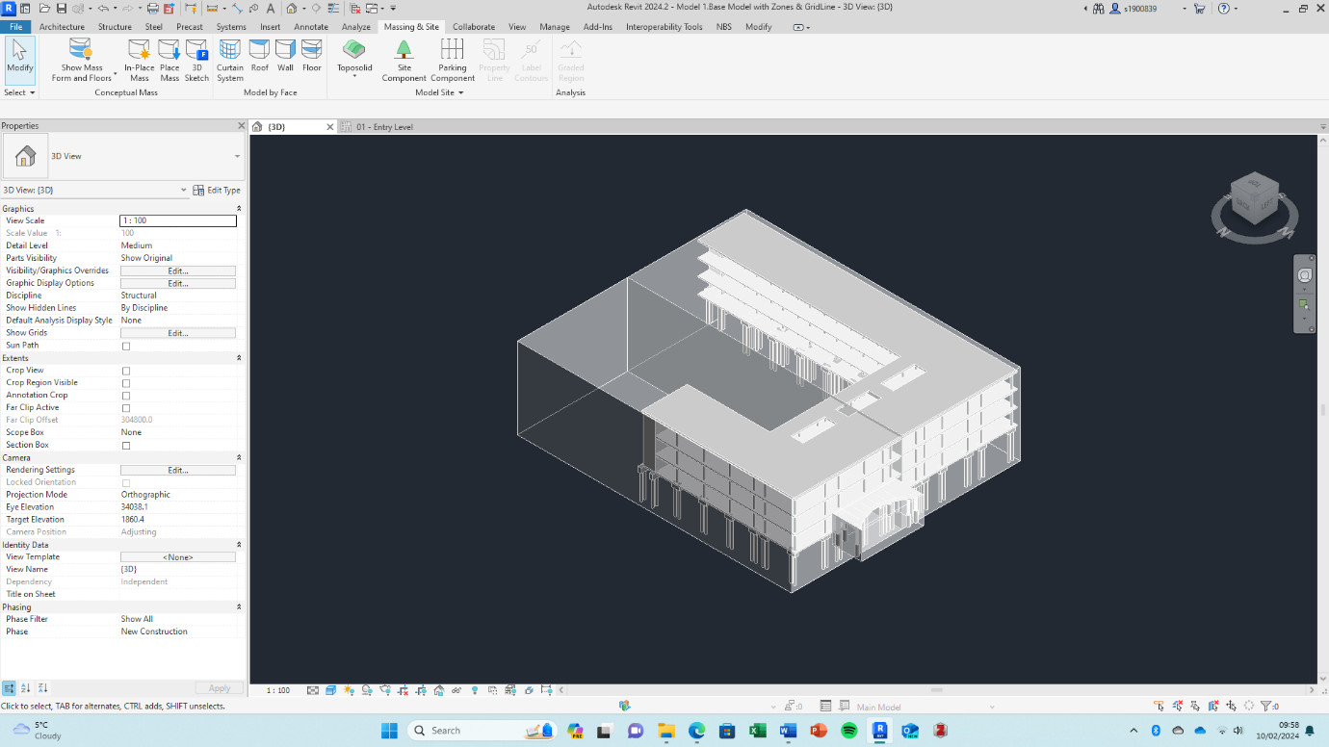

  - 3.1 Manual Parting
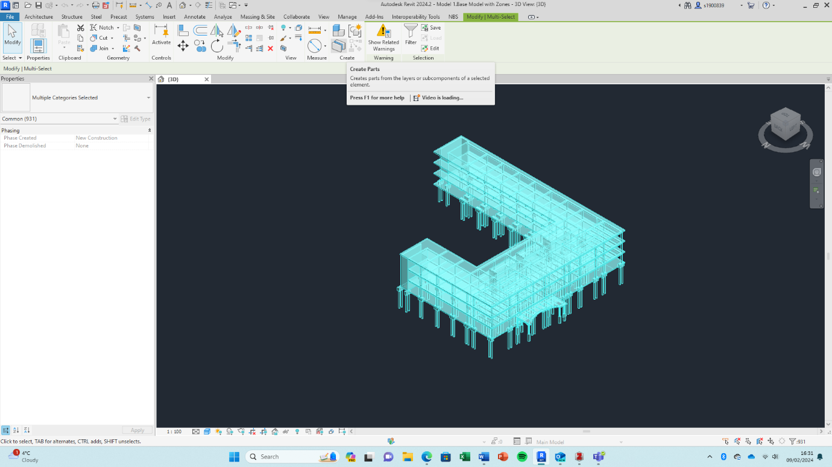
As we need to part the slab and stairwell walls we are required to create parts of all the elements as the method requires us to work with a model consisting entirely of elements or parts, not both (check this against new script for removing parents) .

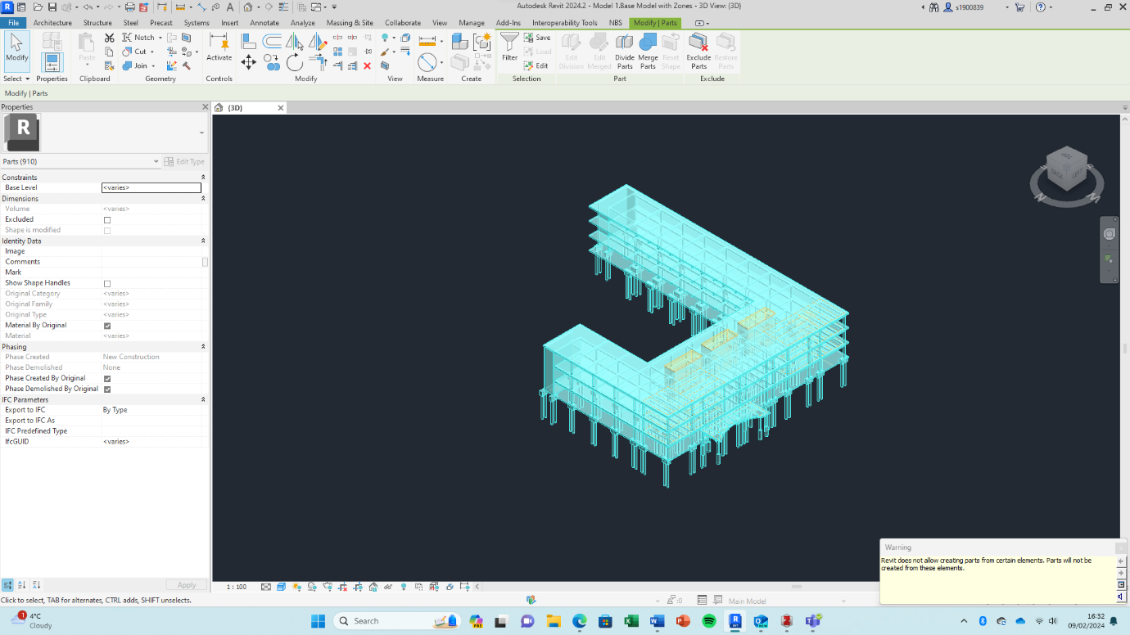

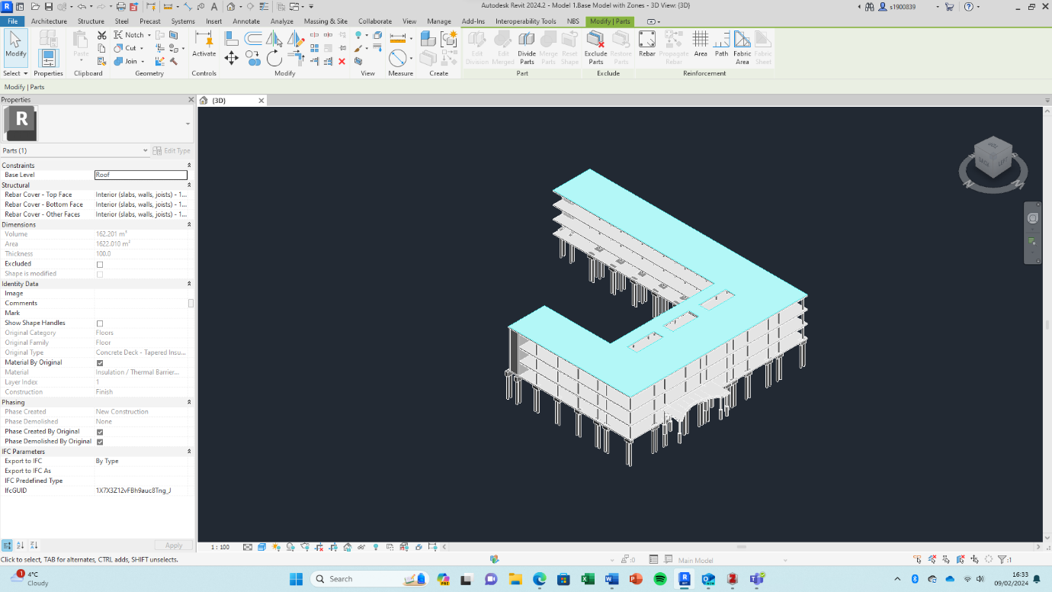
  - 3.2 Dividing Parts
If the model has been modelled correctly then dividing parts shouldn’t be required for vertical elements (i.e all elements should be modelled spanning only 1 floor rather than multiple). If not then additional dividing will be required. Slab elements will also need to be divided based on the construction plan/template however this will be done automatically using dynamo.
Wall dividing:
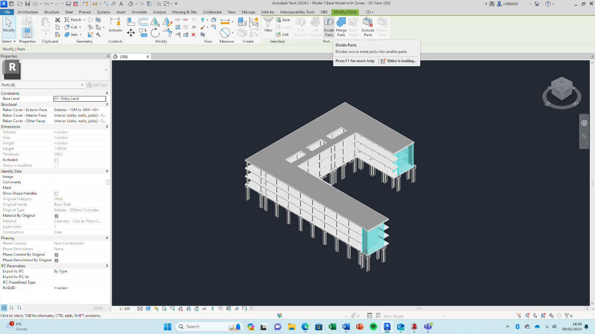

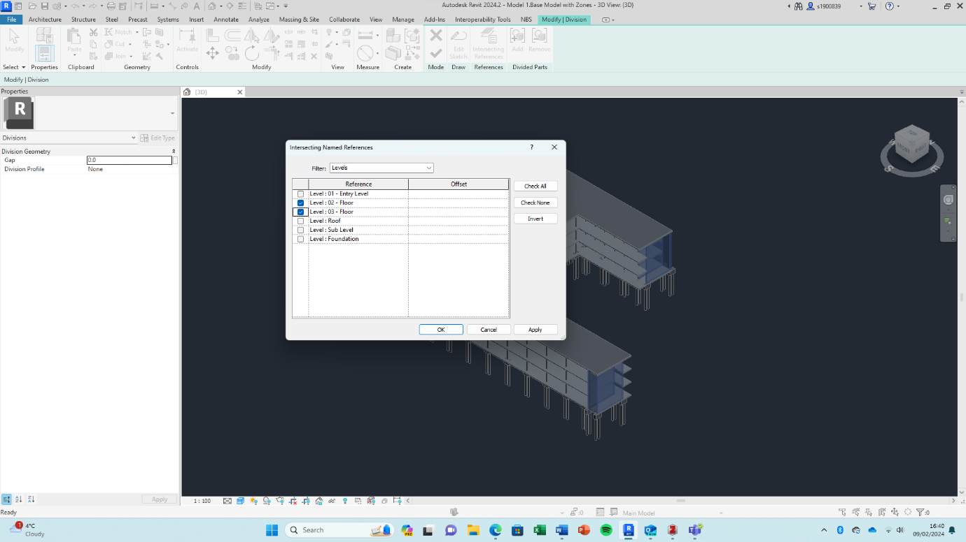
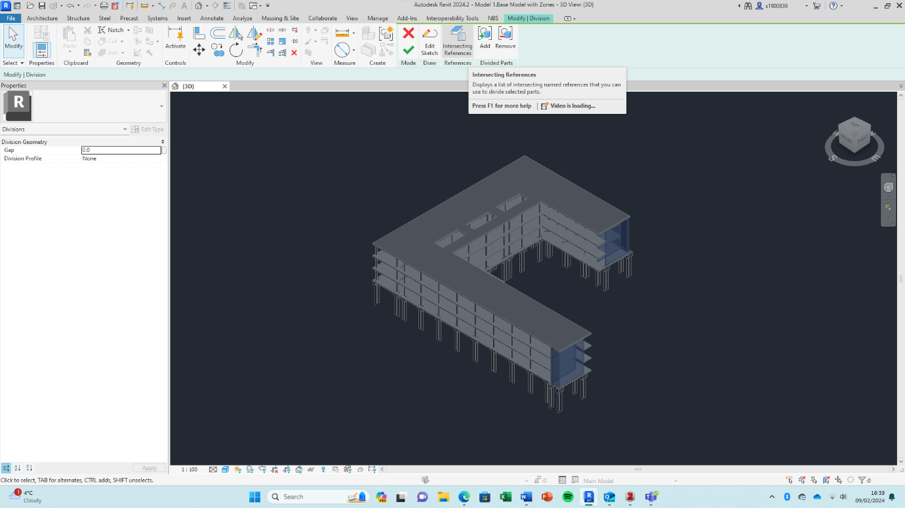

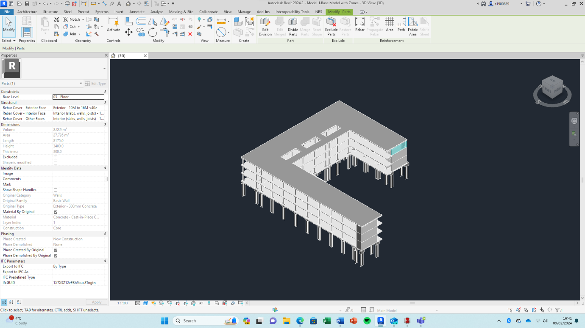
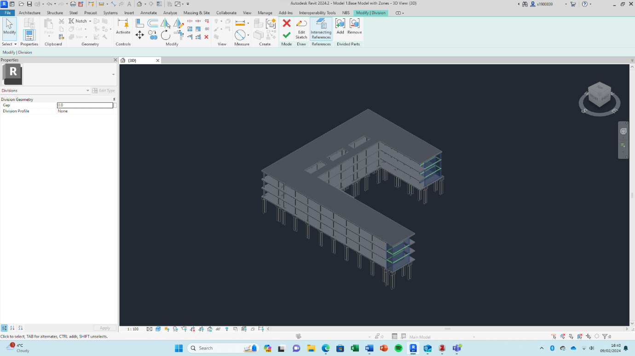

Slab dividing:
Given the area of the entire slab, it is not realistic to expect the entire slab to be created at once, therefore it needs to be divided. The appropriate location/s to divide the slab is in line with the construction zoning provided in the construction plan/template (between Zone A and B). The user will need to choose an appropriate existing grid line or create a new grid line and label it DL01. (Division Line 01), a dynamo script has been created to automatically divide all the slabs at this grid line, reducing the manual input required at this stage. Try automatically get grid line rather than having to select it.
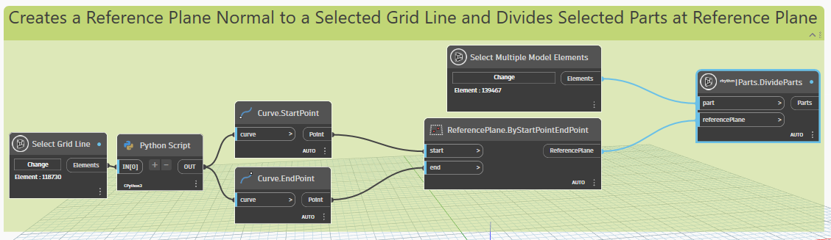
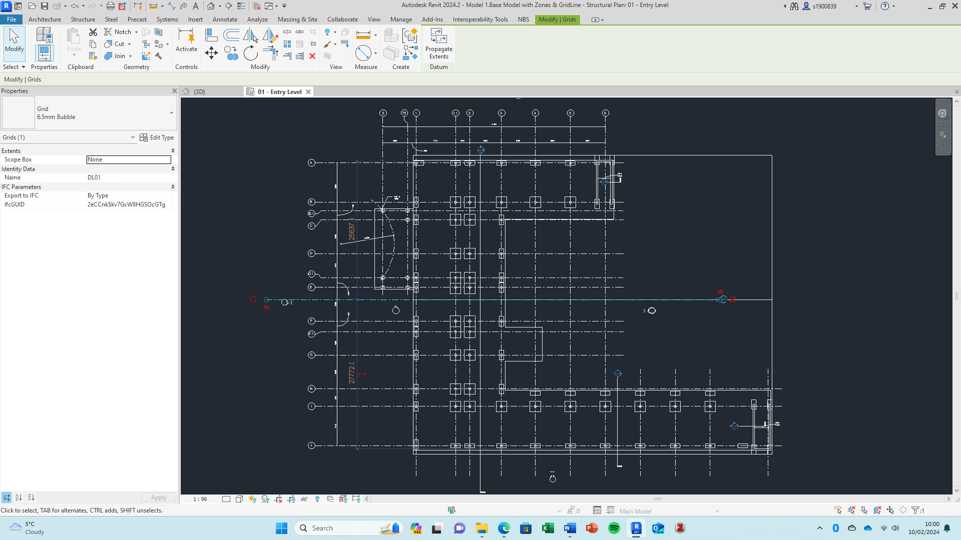

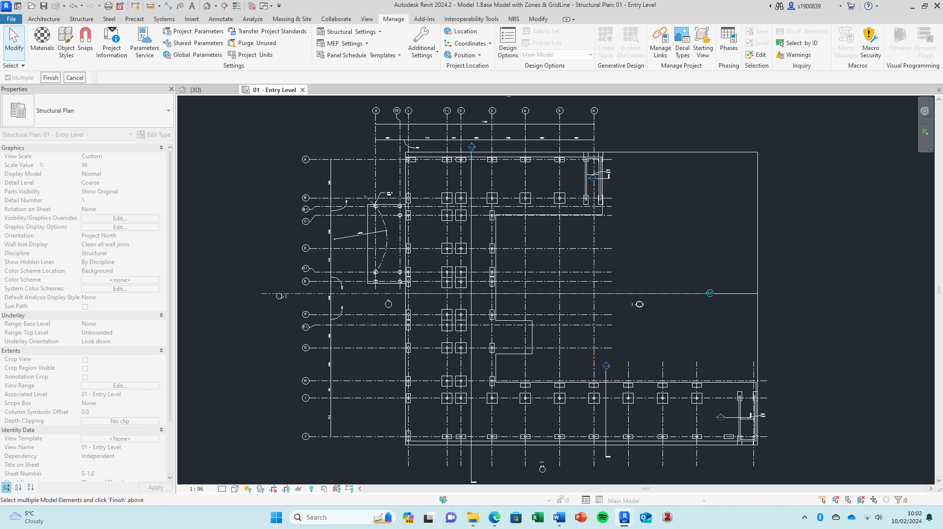
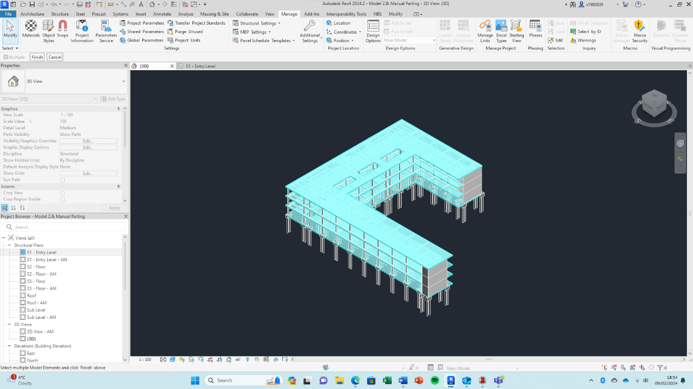
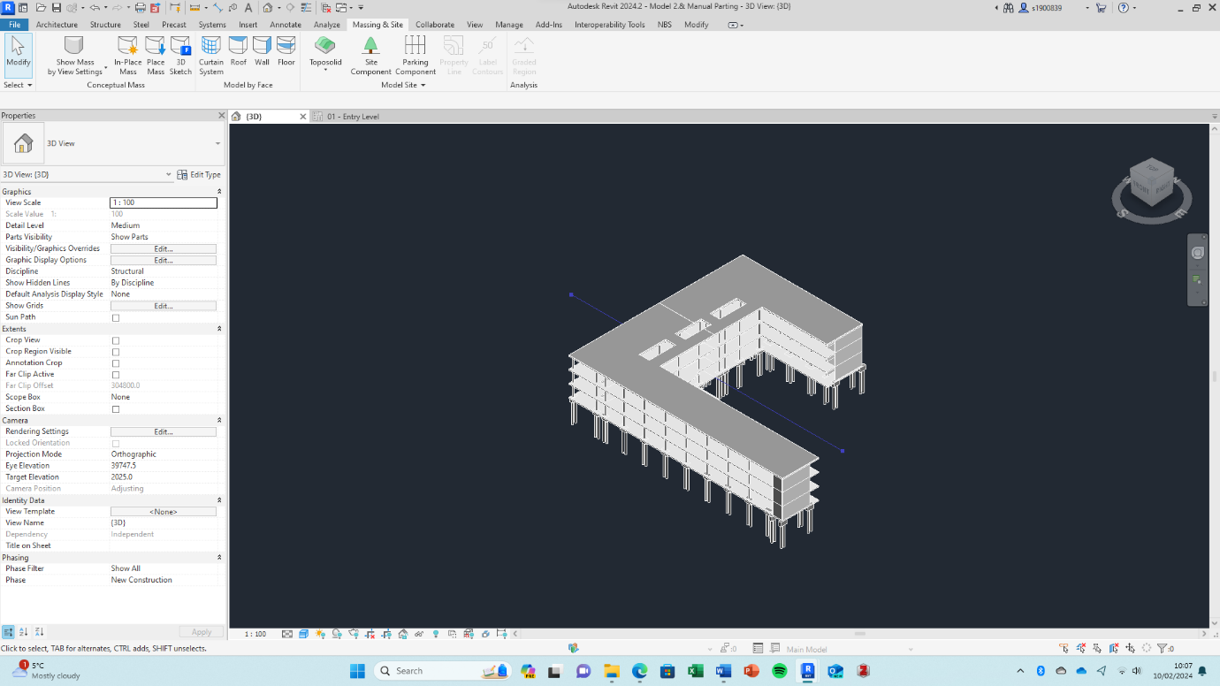
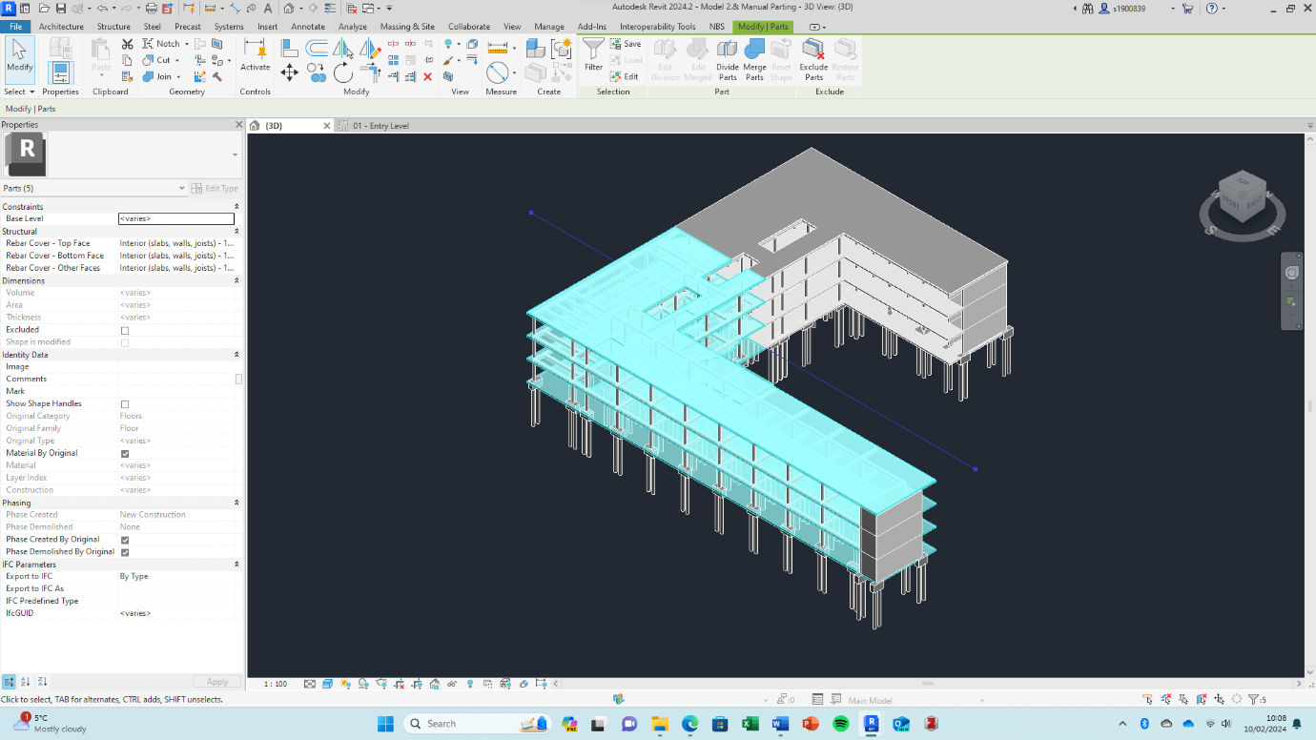

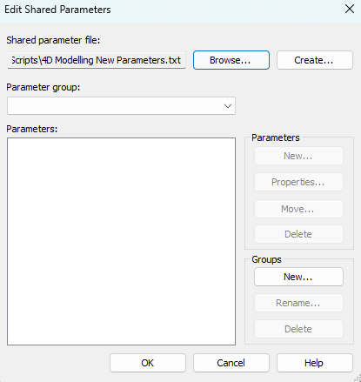
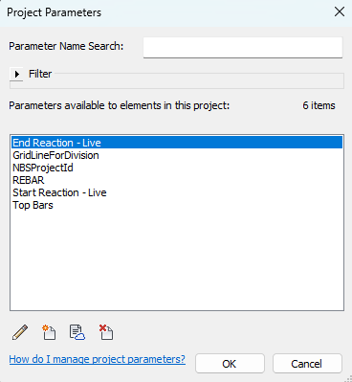
  - 4. New Instance Type Parameter’s for 4D Automation

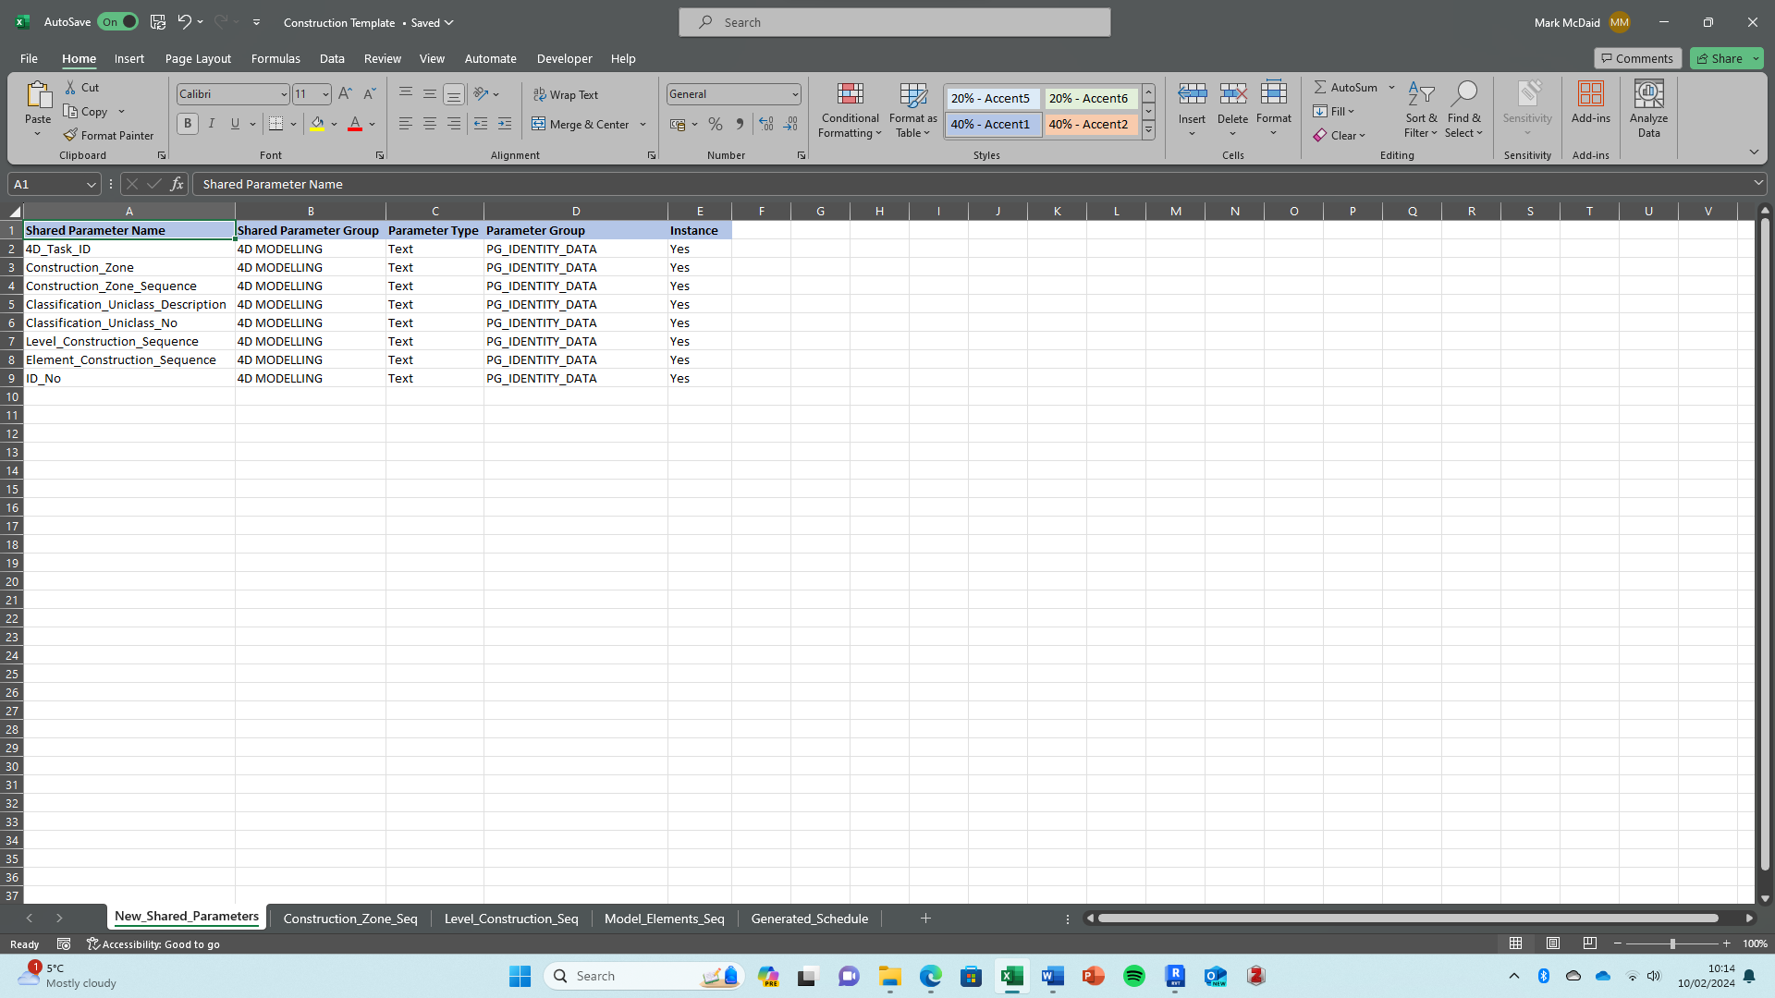
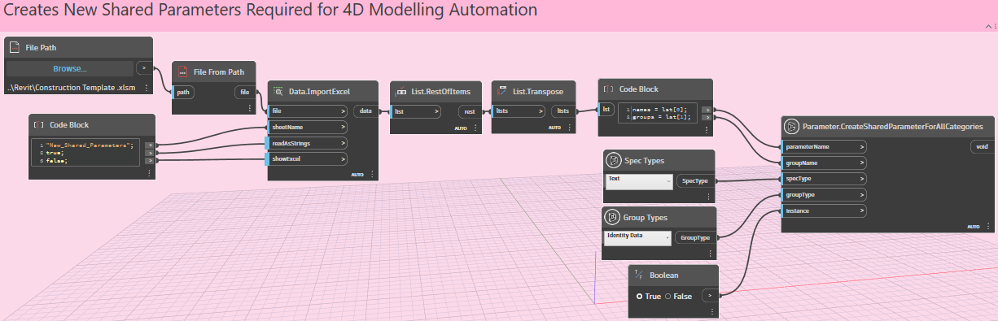

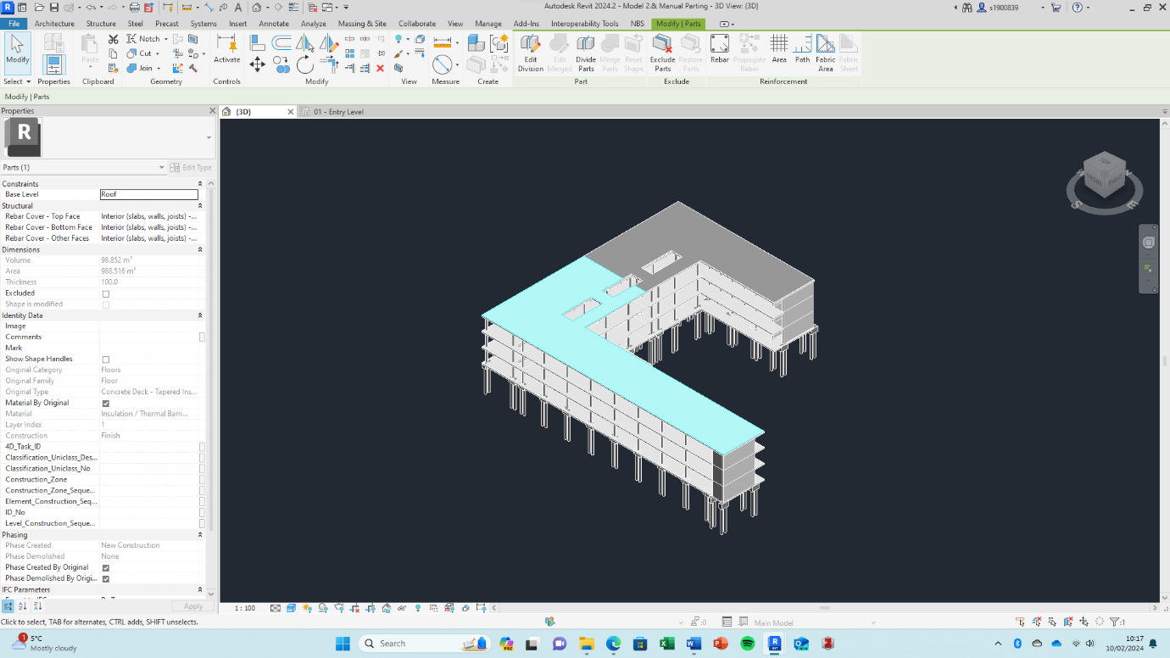

  - 5. Uniclass Descriptions and Numbers for all parts
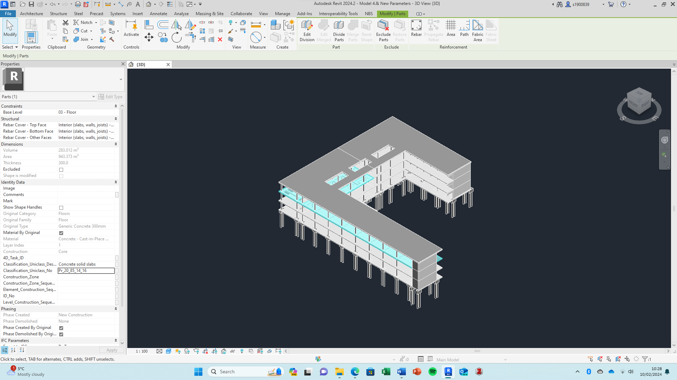
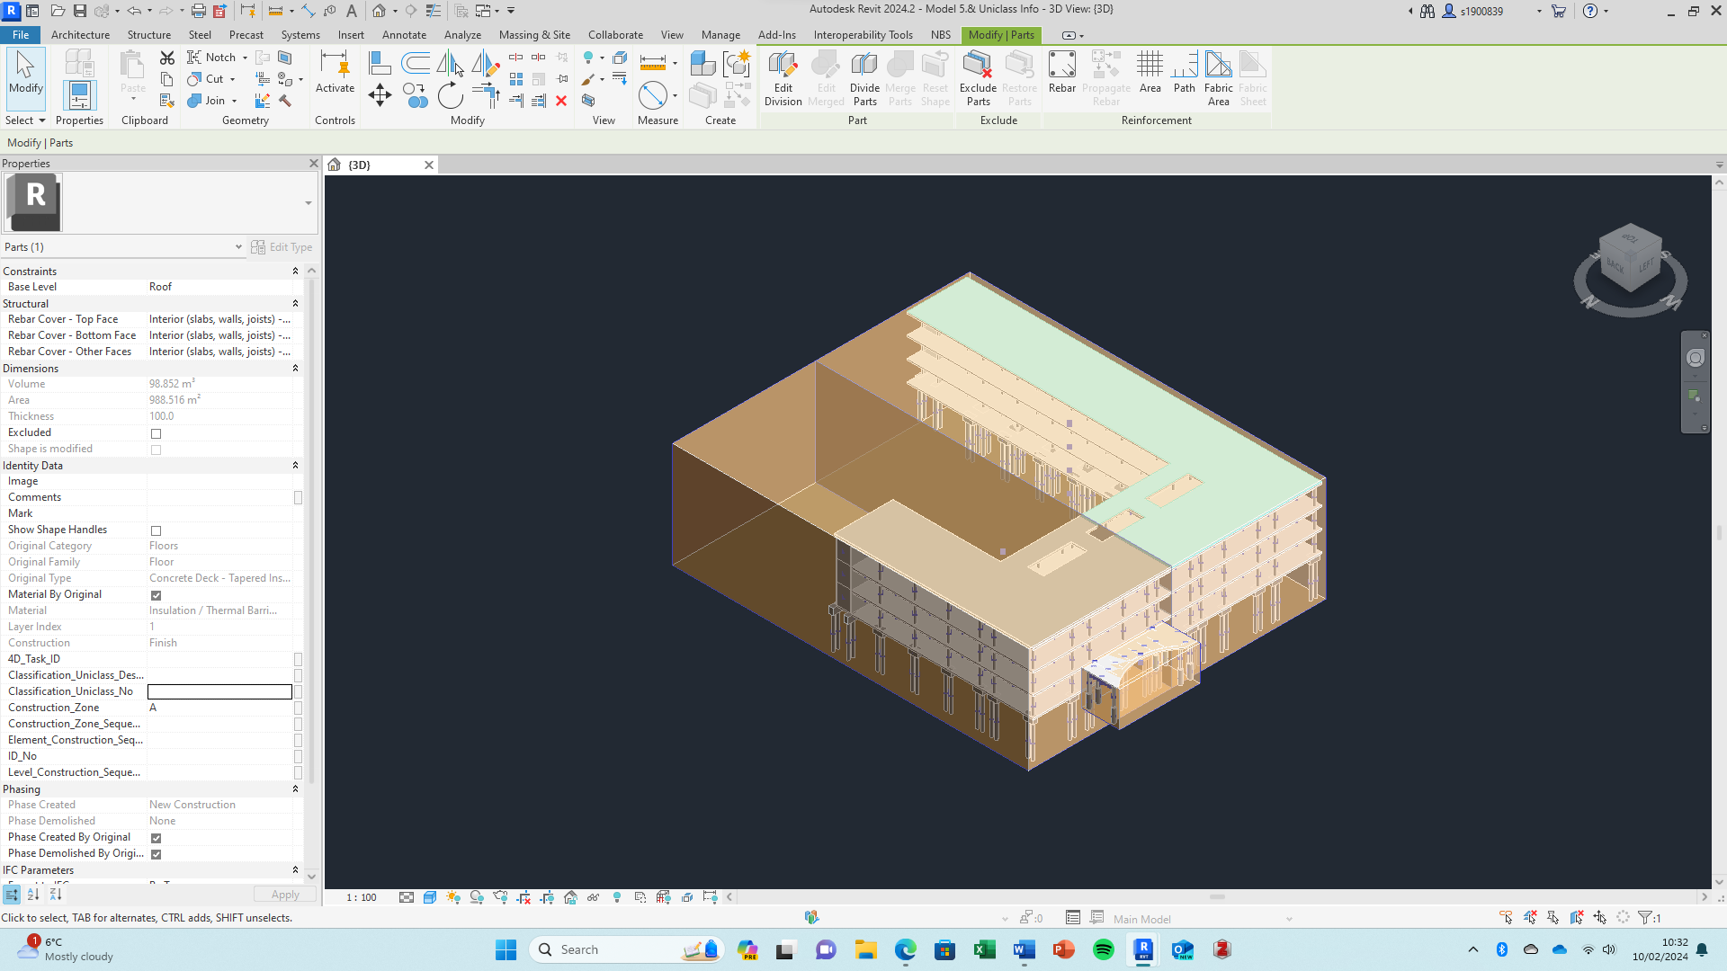
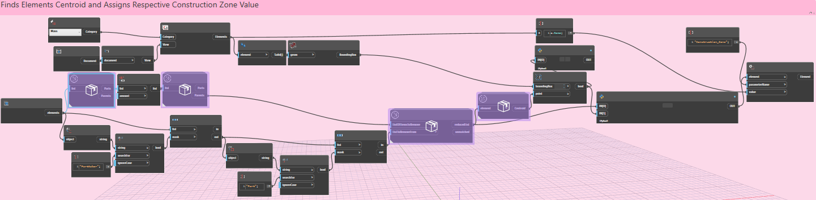
  - 6. Construction Zone Assignment

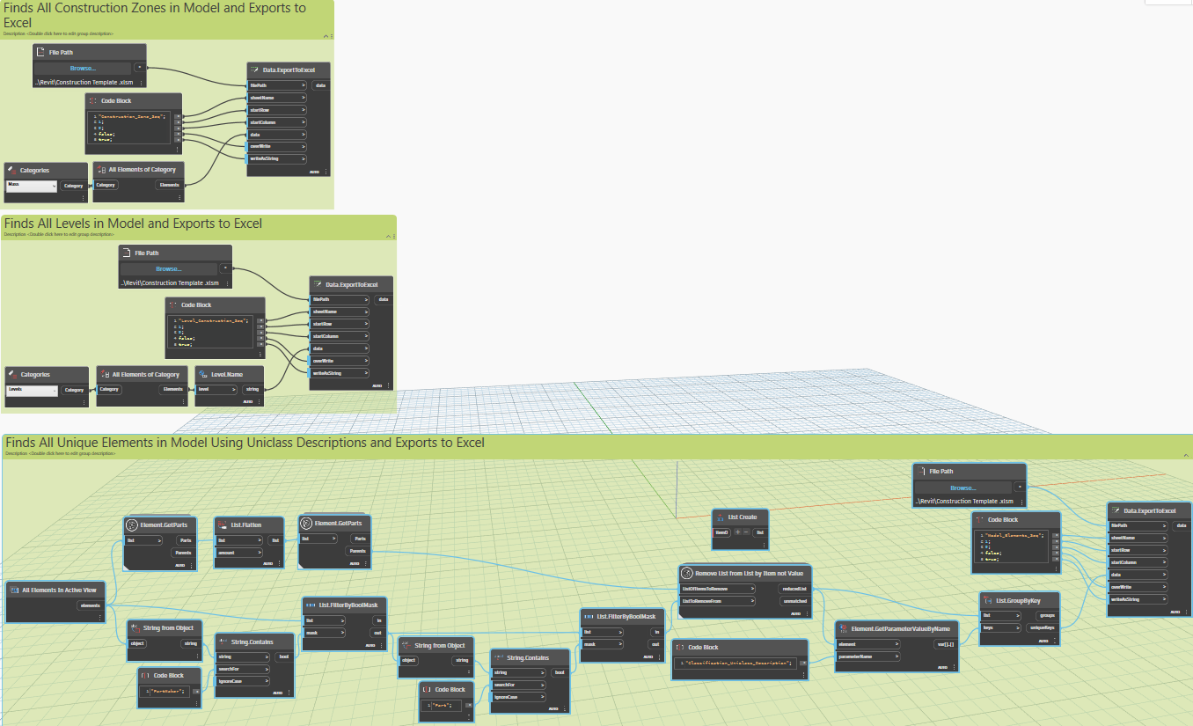
  - 7. Unique Zones, Levels and Elements in model and export to construction template
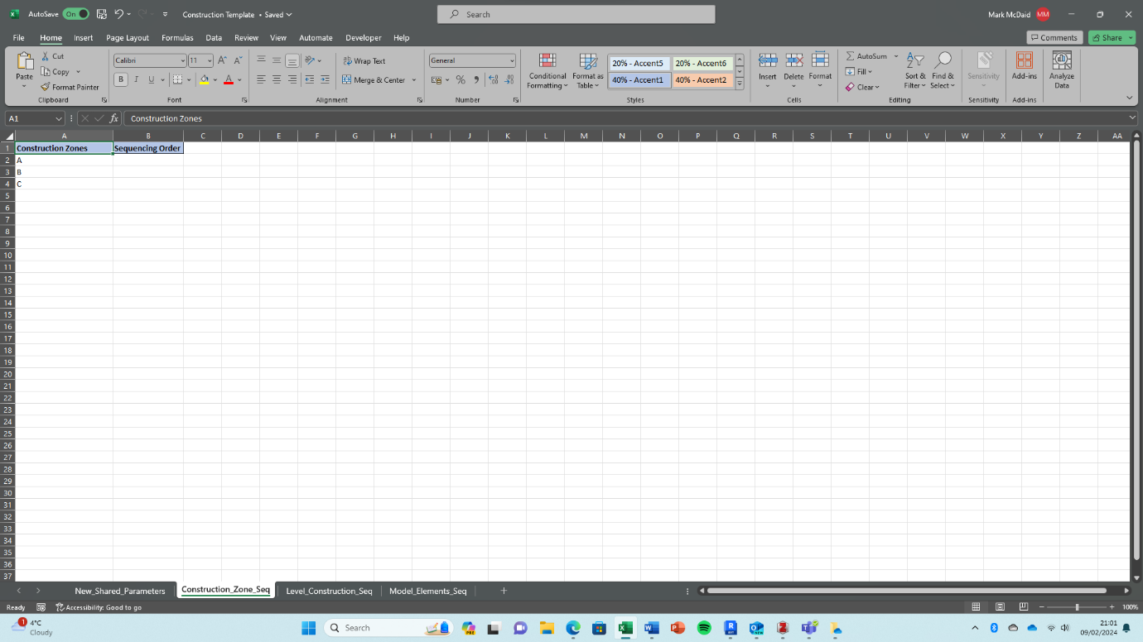

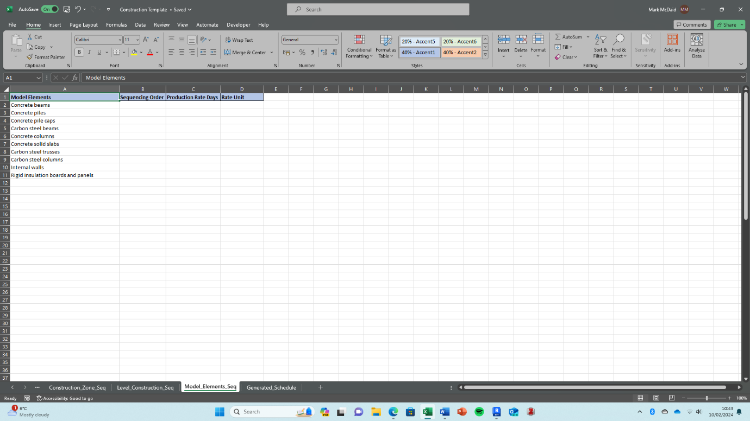
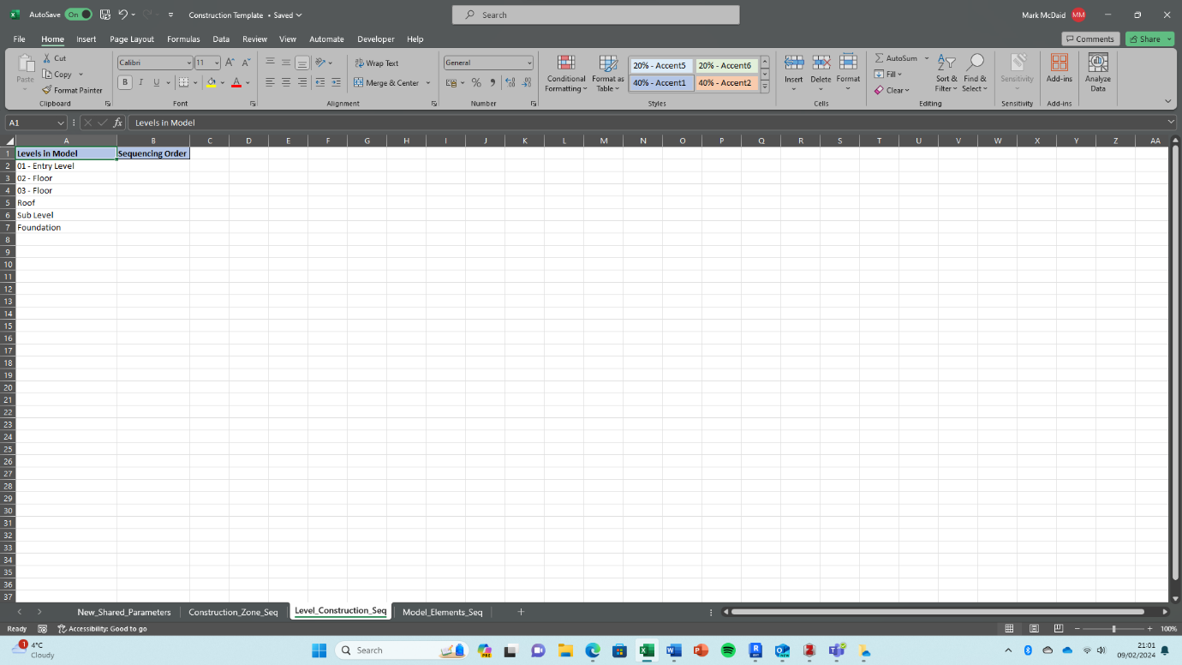

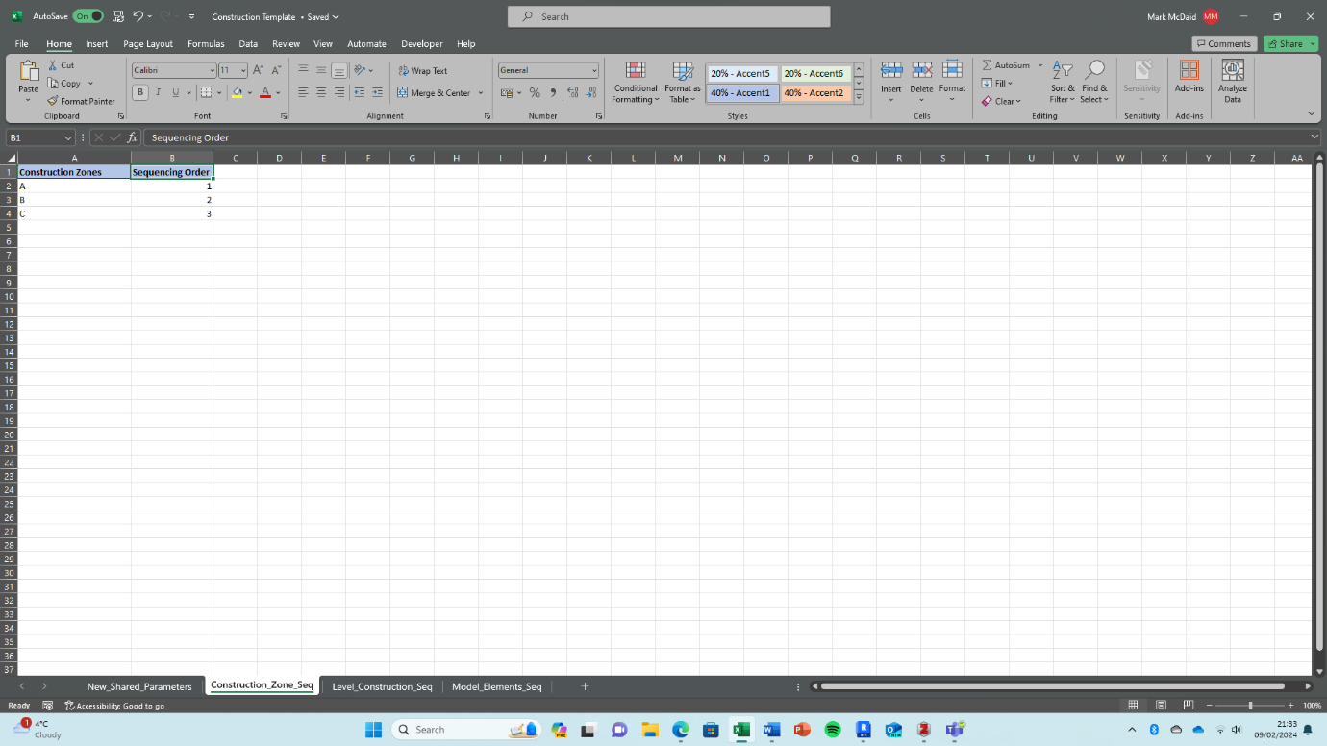
  - 8. Populate sequencing order and rates in the construction template
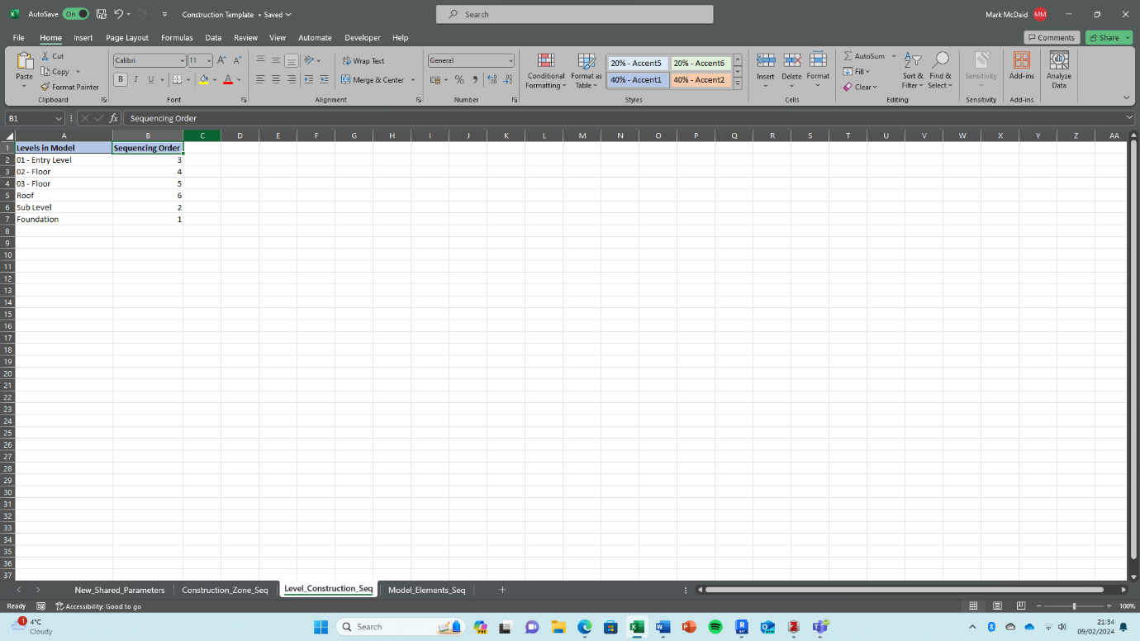

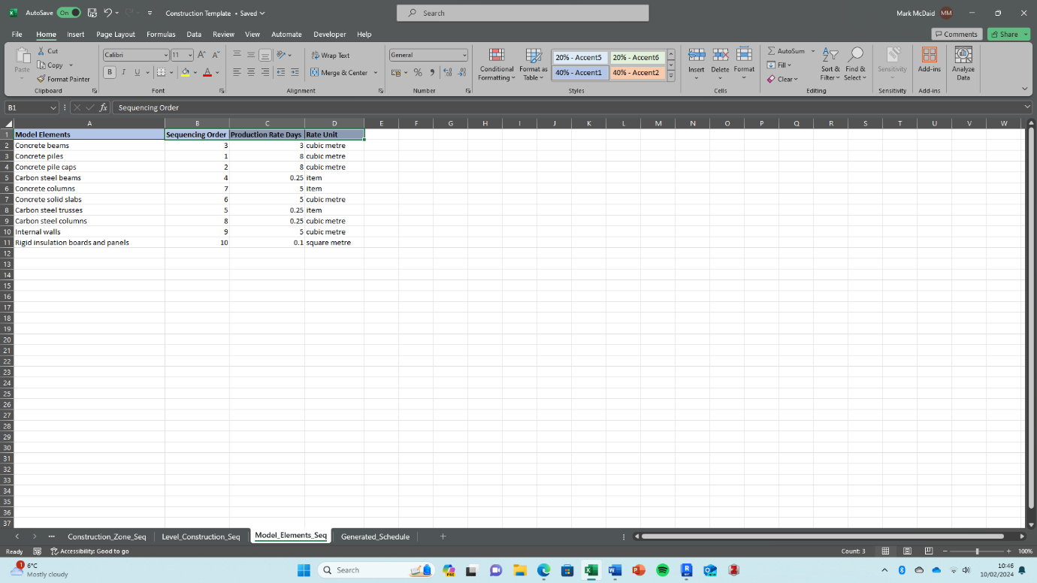

  - 9. Assign sequencing order values from the construction template
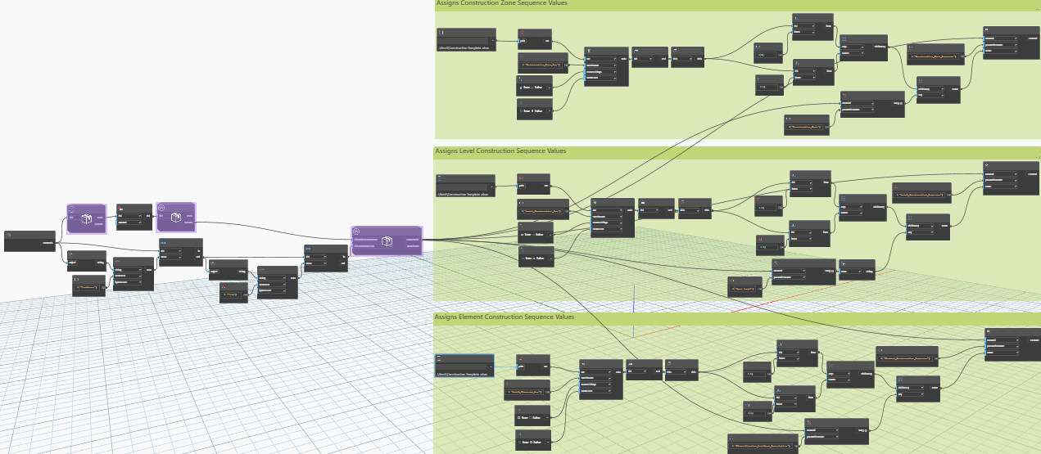

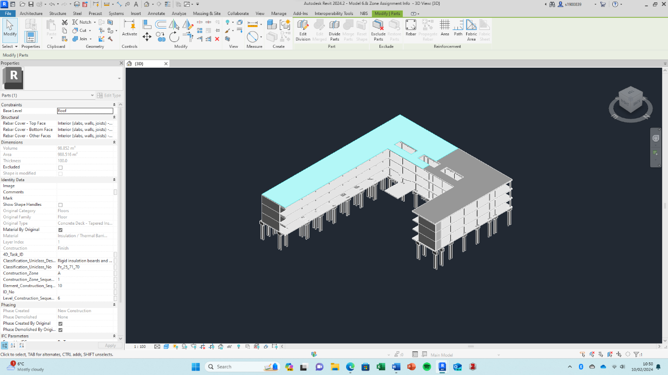
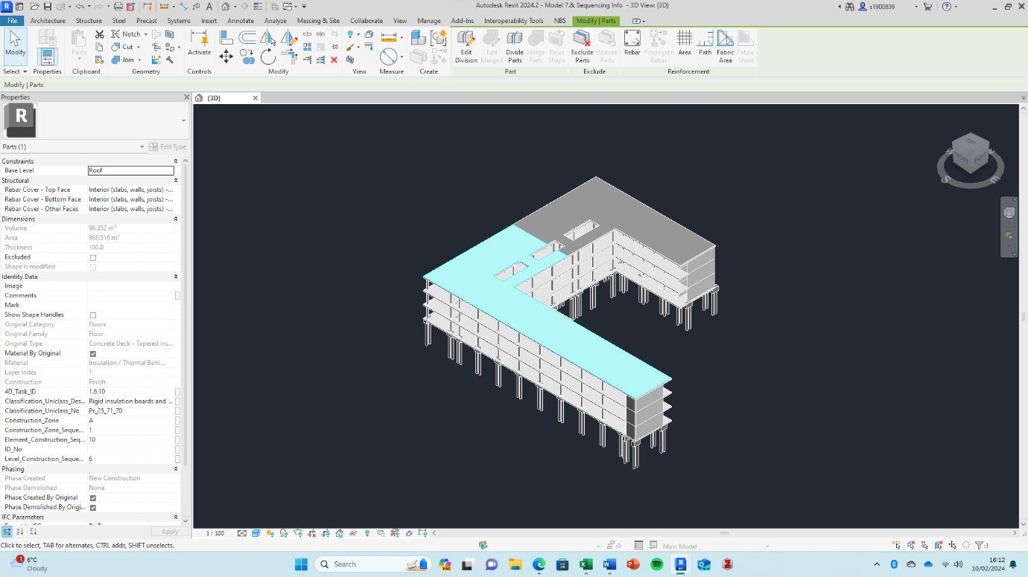
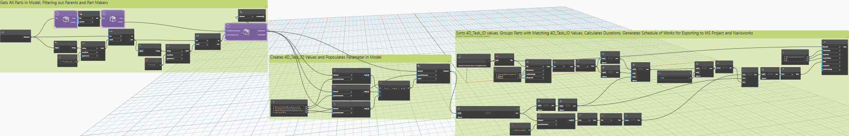
  - 10. 4D_Task_ID Population, Sorting & Schedule Population.
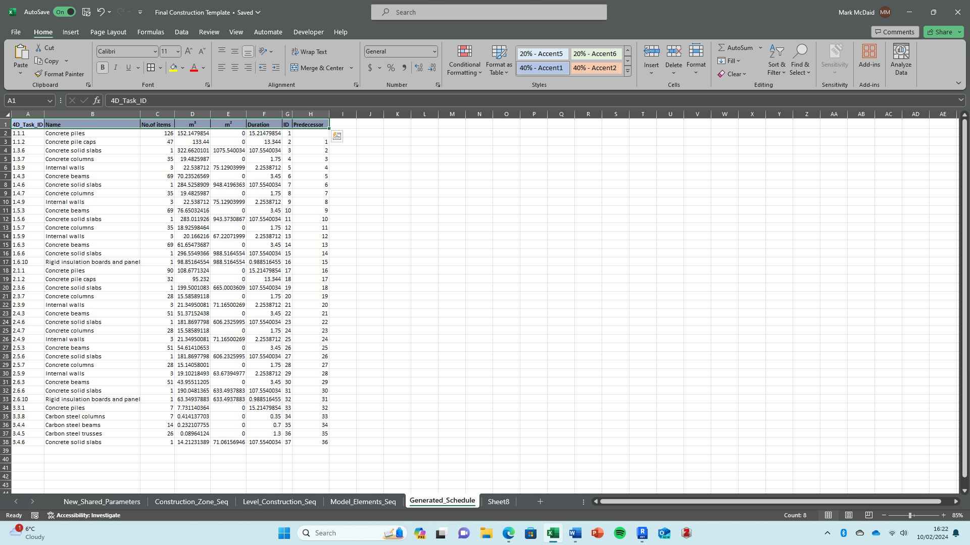
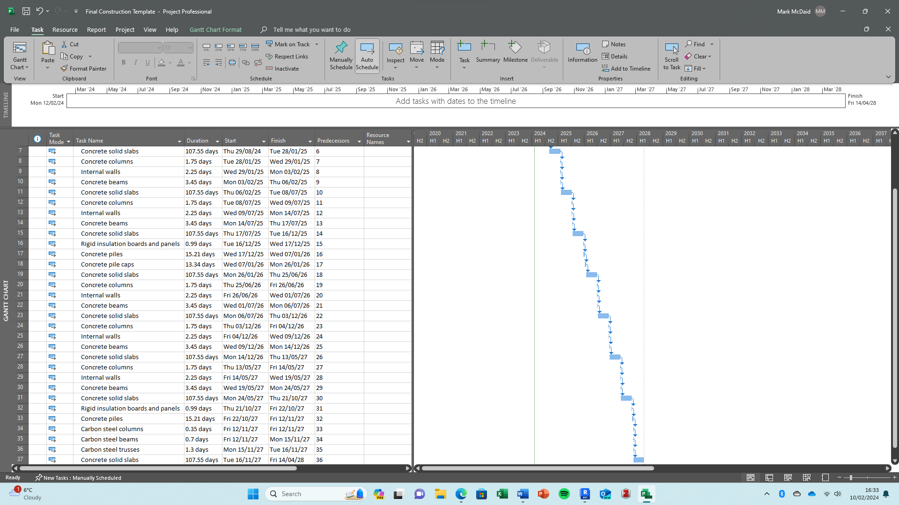
  - 11. Export to MS Project

